tMap



Guided by:- Group members:-
Vishali Wangikar Mam 1.Sarjil Shah
Shubhangi Kale Mam 2.Akshay Umale

Overview of tMap

tMap is an advanced component, which integrates itself as plugin to Talend Studio.

tMap is one of the core components of Talend Studio and is used very often in Jobs. The tMap component is primarily used for mapping input fields to output fields and transforming the input data in the Expression Builder of the corresponding output column.

tMap transforms and routes data from single or multiple sources to single or multiple destinations.

Creating A Job

- To create a job first right click in Job Designs and create a new a new job option.
- Then input a name and purpose for the job and click on create.
- Your new shall be created.

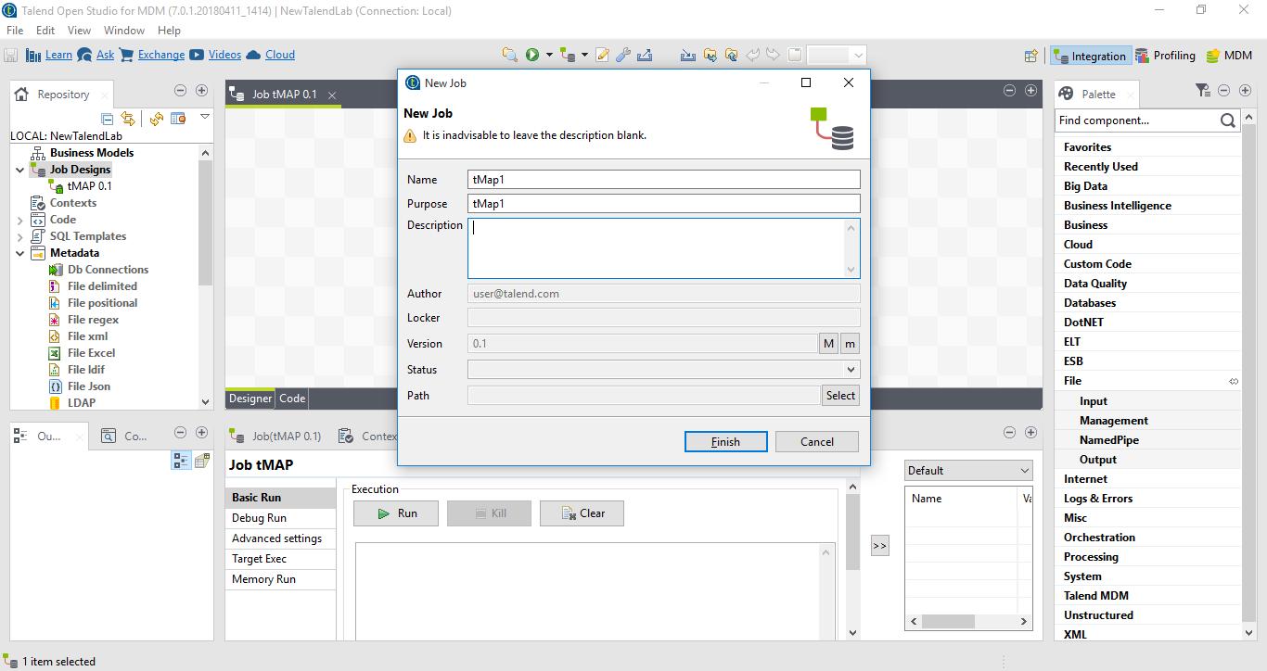

Creating Input and Output Files in tMap

- For adding a input file click on file delimited and then
- Add a name and purpose in step 1.

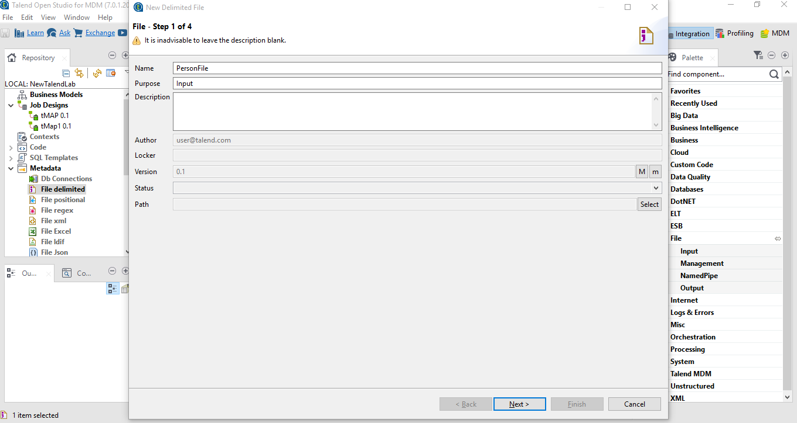

- In step 2 browse and select the desired file for input.

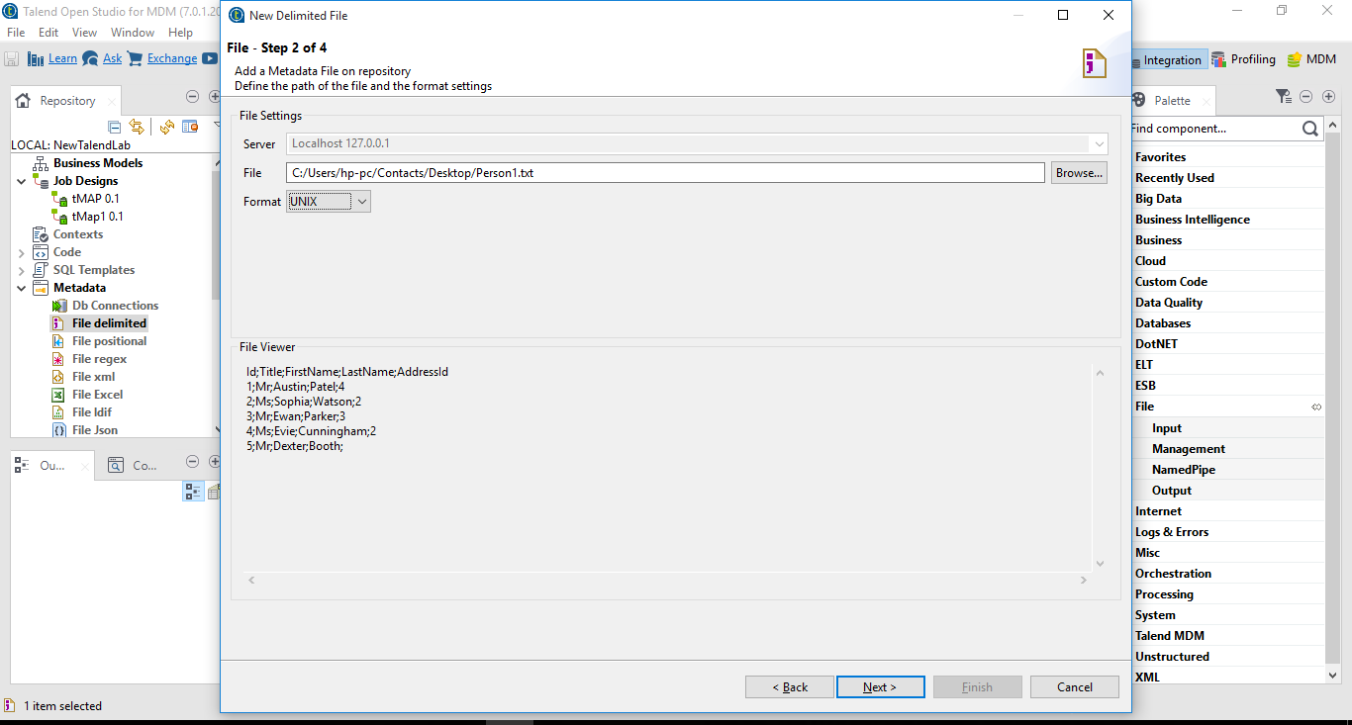

- In step 3 a Check the Set heading option above the table and refresh preview.
- After that click on next follow on to step 4 and your file shall be linked to file delimited.

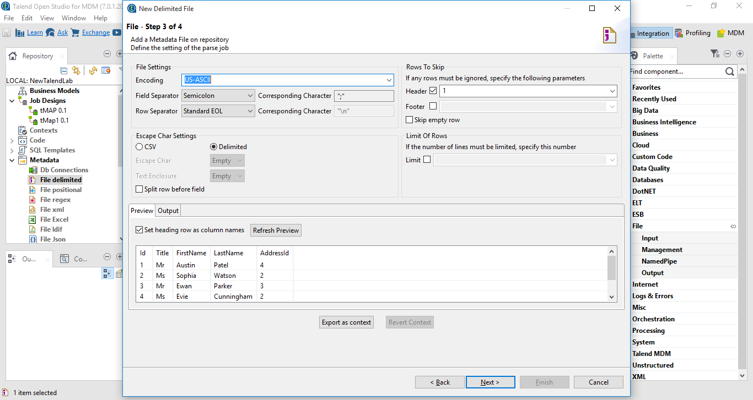

Creating A tMap and Editing Settings

- Add tMap from the processing tab.

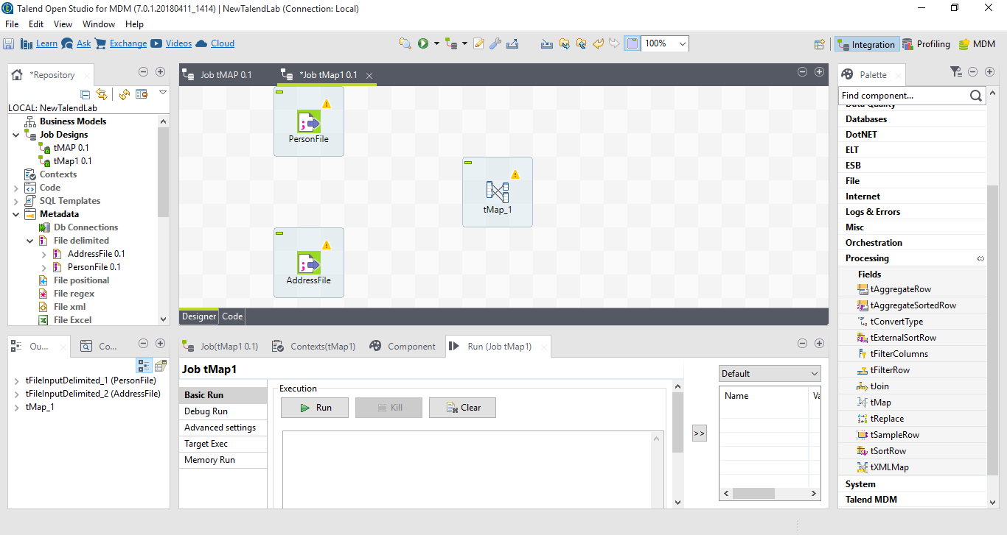

- Add lines to connect input and tMap.

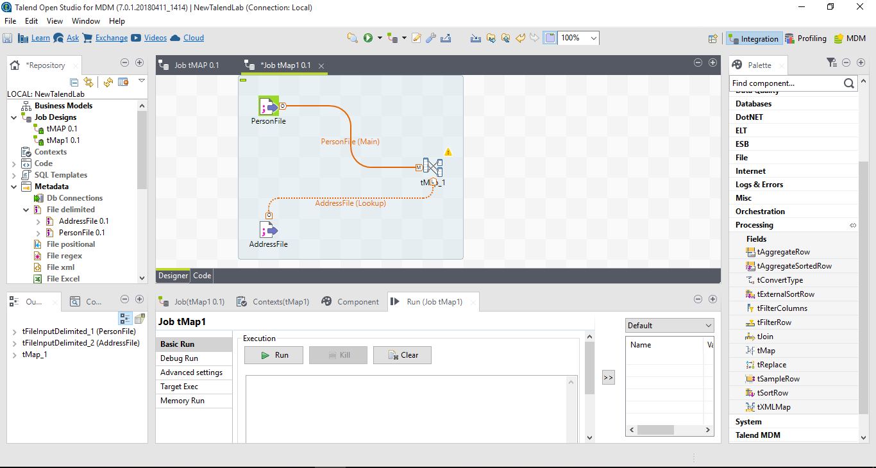

- Add two output files and name one of them “rejects” and other anything you want.
- Also browse two files from any location on pc.
- Connect tMap and output files using row option.

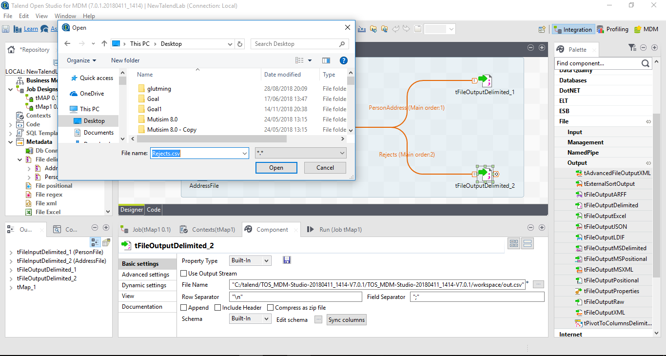

- Double click on tMap to edit tMap settings.

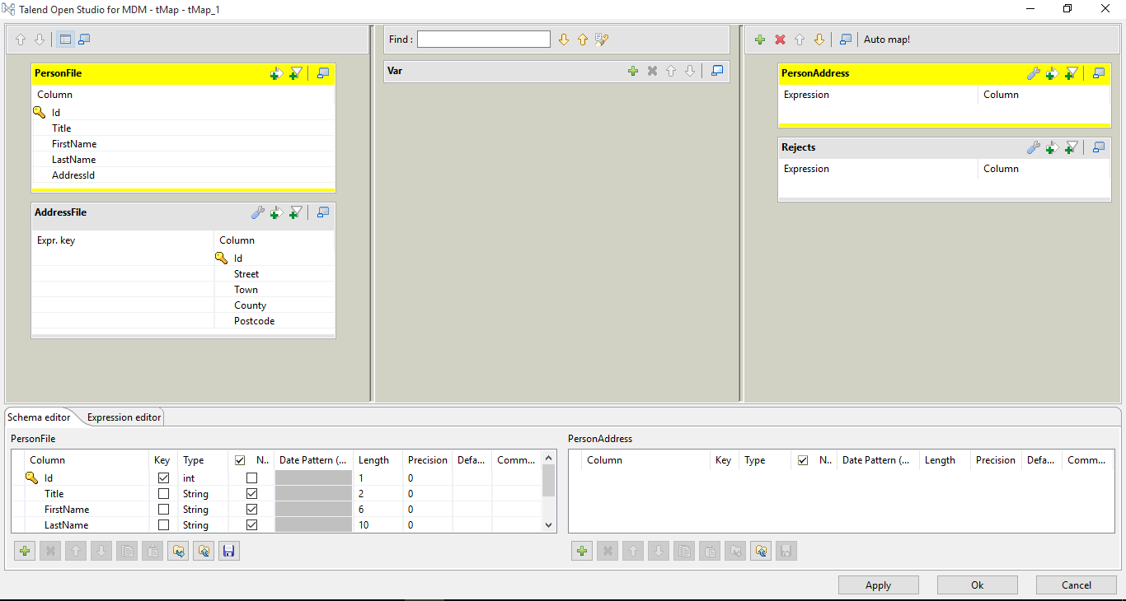

- Copy all the table contents from the two tables and place it in the output table.

- Delete any data columns that comes twice.

- Then press auto-map to synchronize the data column from input tables and output files.

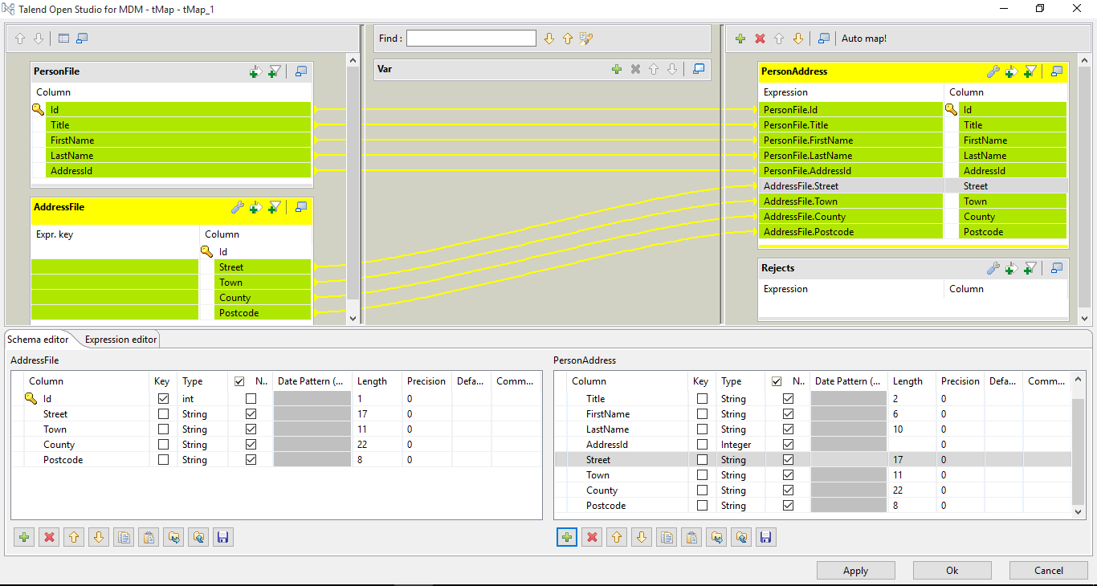

- Add expressions to tMaps so that you can create inner join and place it in output table.

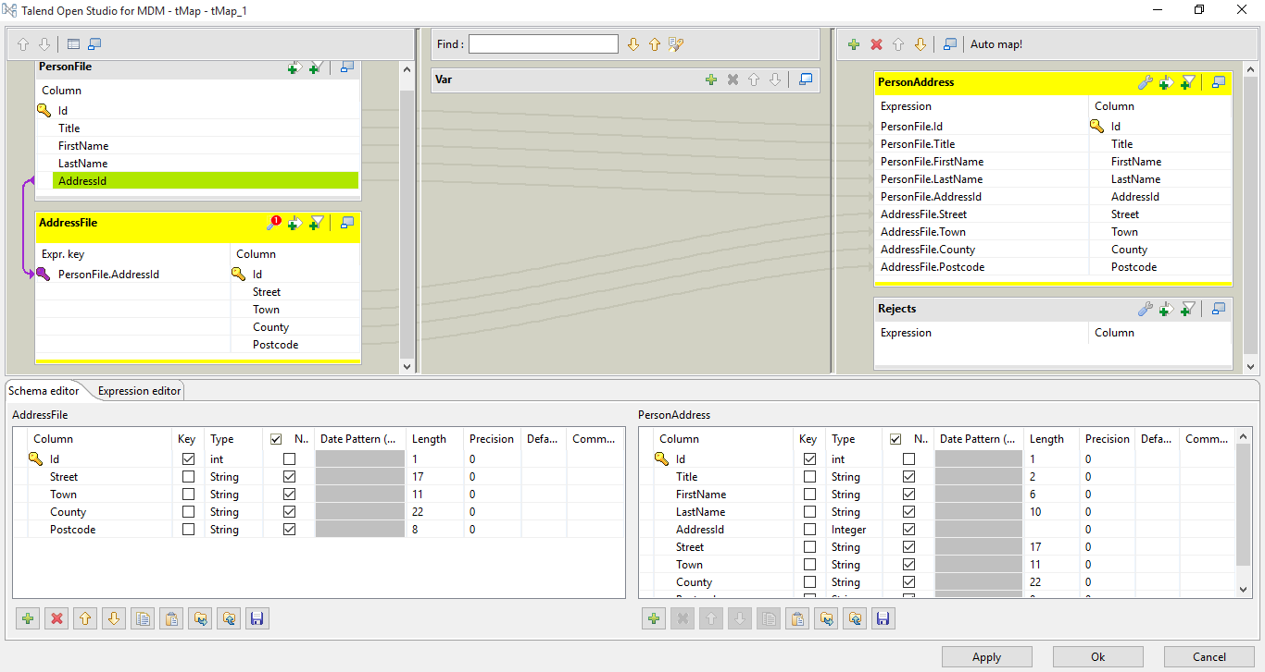

- Also edit the settings to inner join in the setting on look-up table.
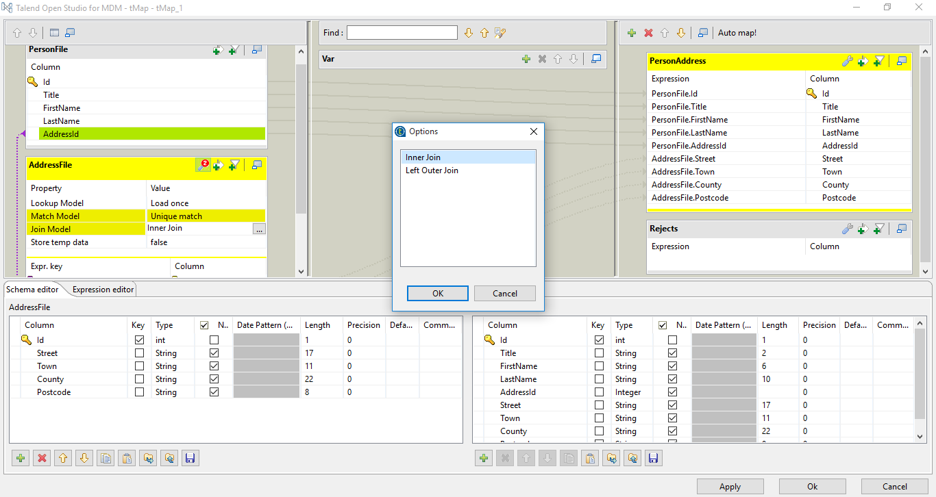

- Edit the “reject” output table in the and add all the columns from the input.

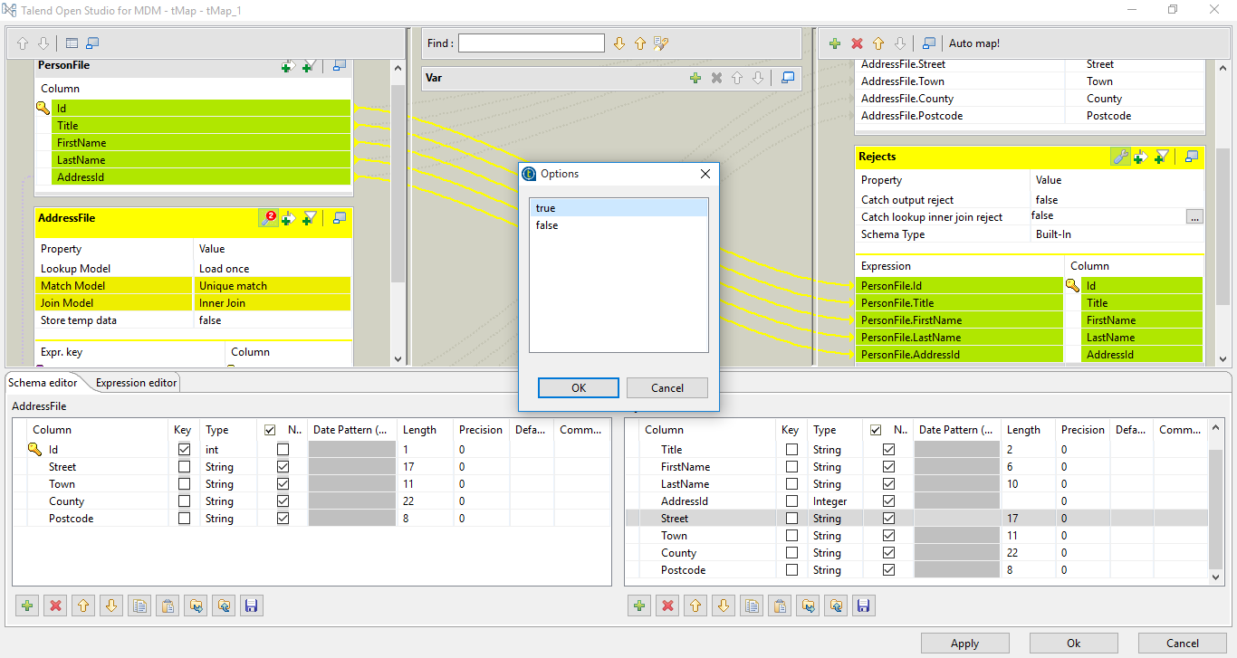
Running Job and Viewing Output File

- Now run the job from component menu.

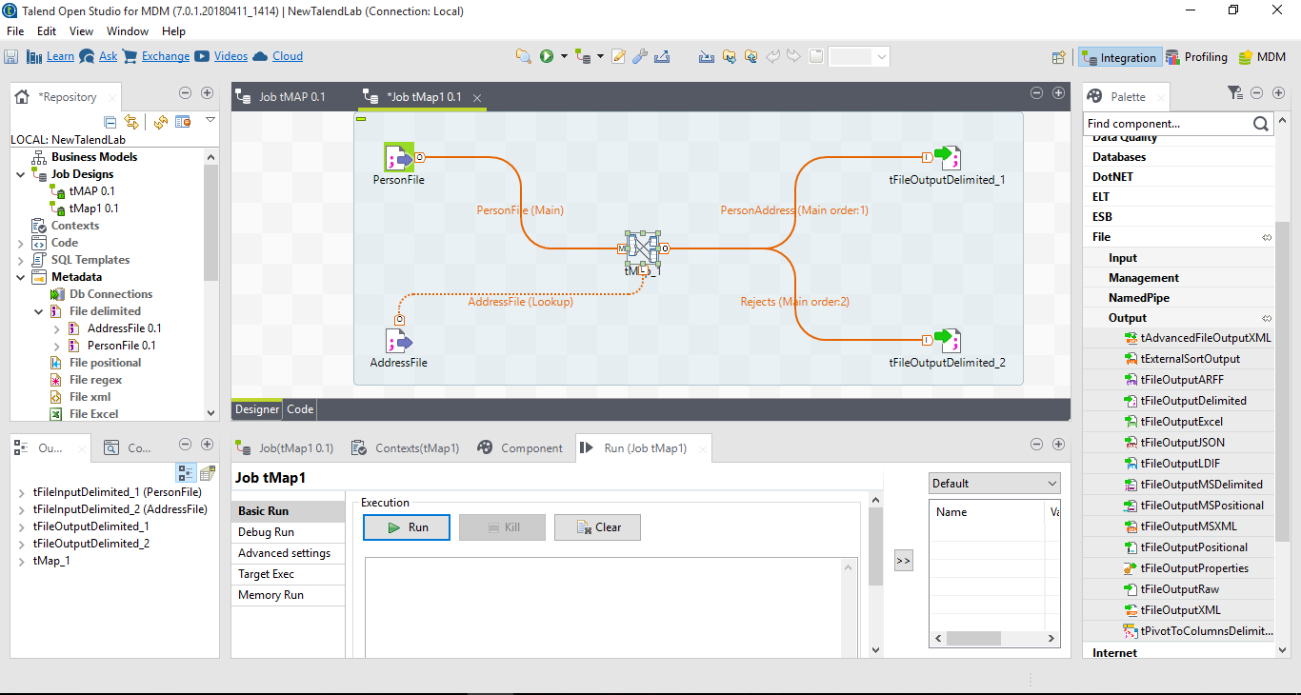

- Voila! You have completed the your first tMap job.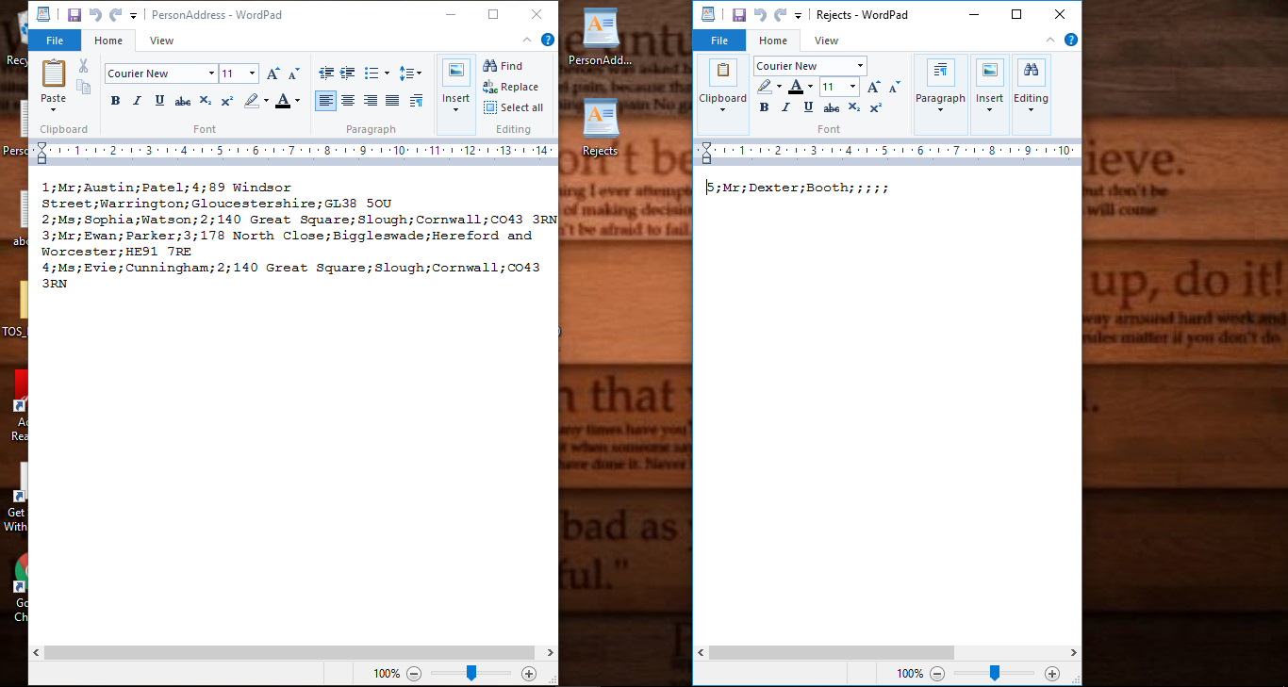

- Now to add new feature to your learning open tMap and click on “+” in variable column as shown in figure below.

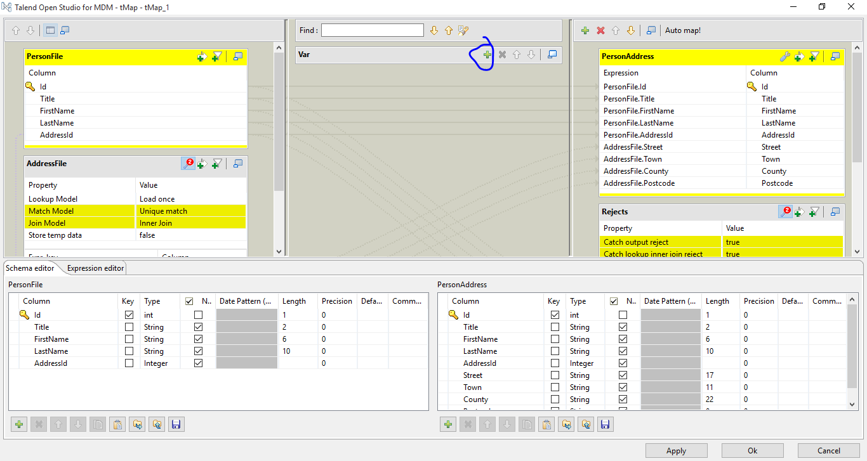

- Here I’m going to add a new variable named “Email”.

- After that gonna add a expression to create email id for people using their first name and last name.

- After creation of variable just drag and drop the column in output files.
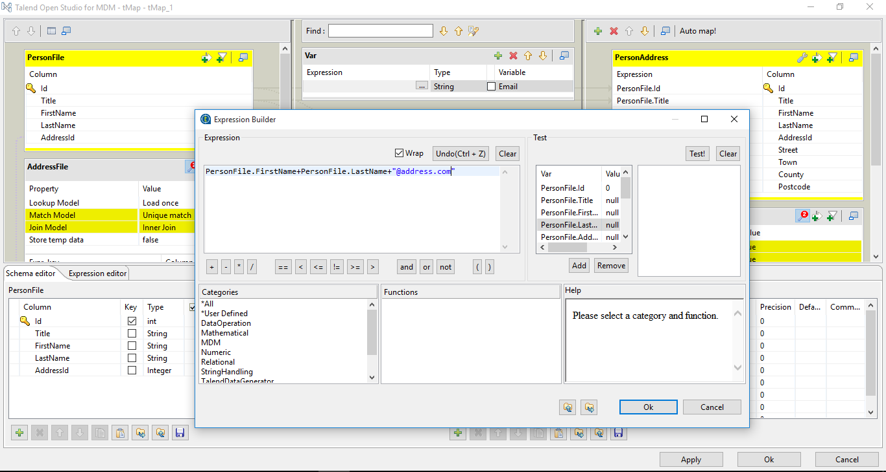

- After adding and running the job you will get output similar to this.

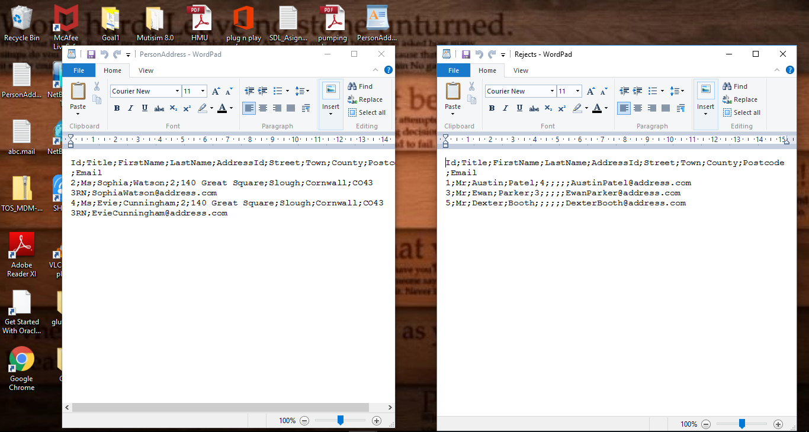

Using Expression Filter Option

- Expression editor is like a condition statement that puts the output in output table only if the data condition satisfies.

- Here I have added condition statement that if length of first name is greater than 5 only that data should be displayed.

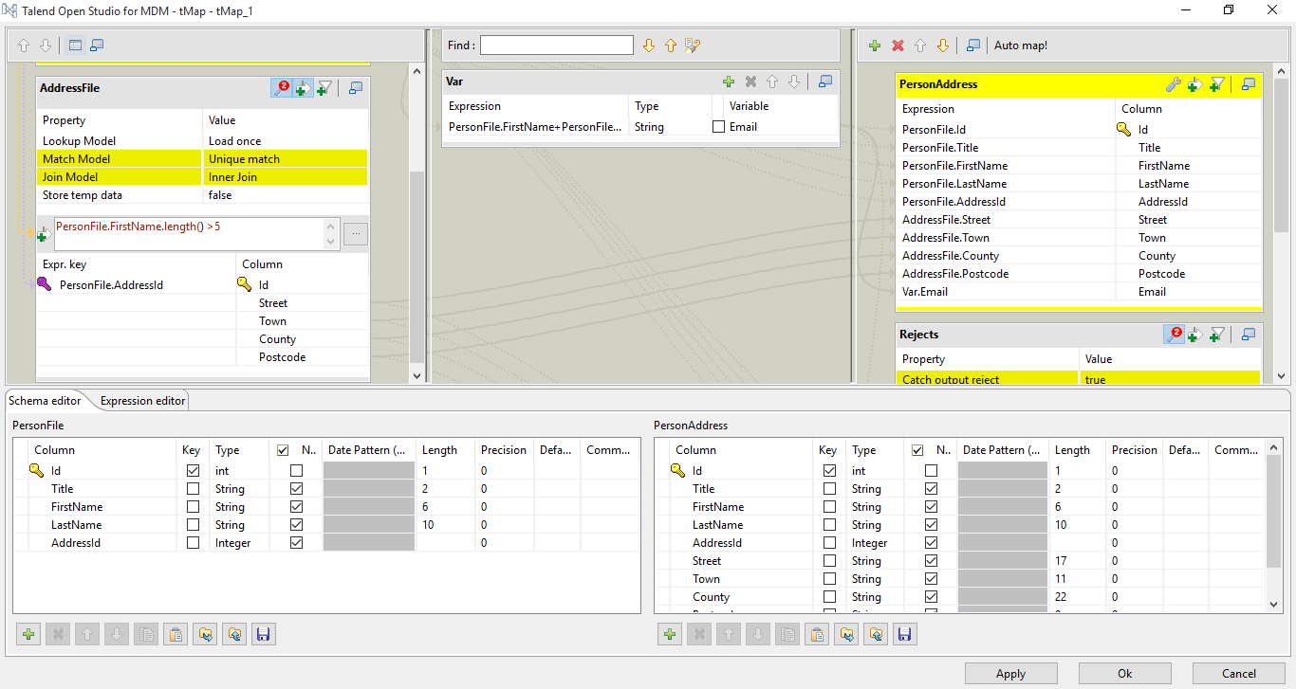

- Output for the tMap with given expression is given below.

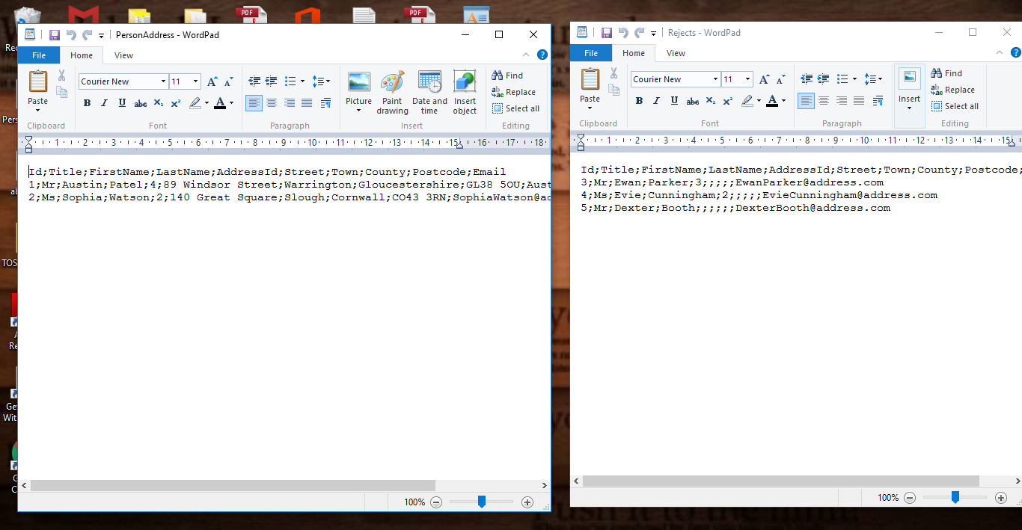

Reference :

https://help.talend.com/reader/wDRBNUuxk629sNcI0dNYaA/mxzKD~8eLuNFSXH6LMi7qg

https://www.talendbyexample.com/talend-tmap-component-joins.html

